Title of Paper (Bold, 14 pt, Times New Roman) First Letter in Every Word Should be in Capital

F. First Author’s Surnameª, A. Presenter of the Paperª, C. Corresponding Author^{b}*(in 12pt, bold and italic)
Affiliation (Department of …, University, City, Postal code, Country Name, (in 10pt, Times New Roman, regular and italic)
Email: … @ ...
Graphical Abstract
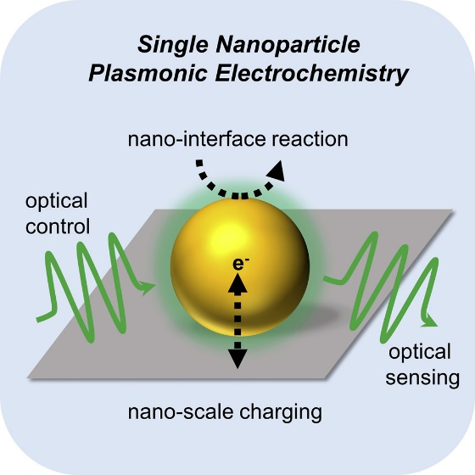
This instruction gives you guidelines for preparing papers for 14th Biennial Electrochemistry Seminar of Iran. The abstract should contain the aim and significant findings of the research (Times New Roman, 12 regular). The abstract should state the objective, results and the conclusion of the work. Use this document as a template if you are using Microsoft Office Word 10.0 or later. Do not cite references in the abstract. The length of the manuscript should be between 250 to 400 words in one page. The authors are requested to upload their manuscripts in MS Word (.docx) and PDF formats through the seminar website. All pages should have the header of the seminar. Please underline the name of author who will present the article in the conference and also indicate the corresponding author with “*” and give his/her Email address as above.
Once the abstracts are accepted, at least one of the authors must register for and present at the conference.

REFERENCES: (Times New Roman, 10pt, regular and italic)
- A. Name, B. Name, and …, Journal Name, vol. -, pp. …-…, Year.

